“Passion for Pastries”

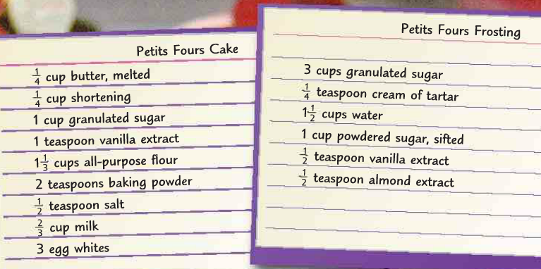

A pastry chef at East End Bakery needs to make petit four cakes for an upscale baby shower at the Peabody Hotel. He will use the recipe above, which makes 24 petit four cakes.

Answer the following questions and then create a colorful bi-folded brochure for East End Bakery to market their petit fours. Petit fours are sold by the dozen. You should list each dozen increment between 12 and 100. One dozen petit fours is priced at $38.79. You should have a single petit four priced in your brochure for customers that want to try one. It should be $1.50 higher than an individual petit four would be in a dozen.

On the back page of your brochure, type one to two paragraphs explaining the difference between a baker and a pastry chef and the education or training required of a pastry chef. Site your references.

Justify your answer by showing your work.

1. The Chef is making only half of the frosting recipe. How much cream of tartar will
be needed? How much granulated sugar will be needed?

2. If the petit four recipe is doubled, how much milk will be needed for the cake?

3. For a wedding, the pastry chef is increasing the recipe 3 times. How much
butter will be needed? How much flour?

4. If the frosting recipe is tripled, how much water is needed?

5. The chef increases the recipe so that it makes 1 ¾ or 1.75 times the number of
petit fours of the original recipe. How much vanilla extract is needed for both the
cake and the icing?

